Osama’s Design Concept:

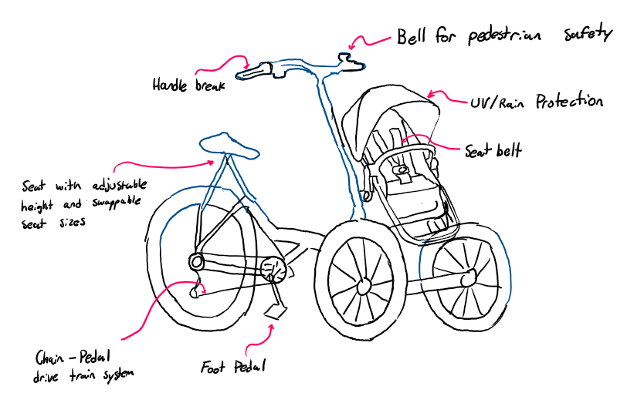

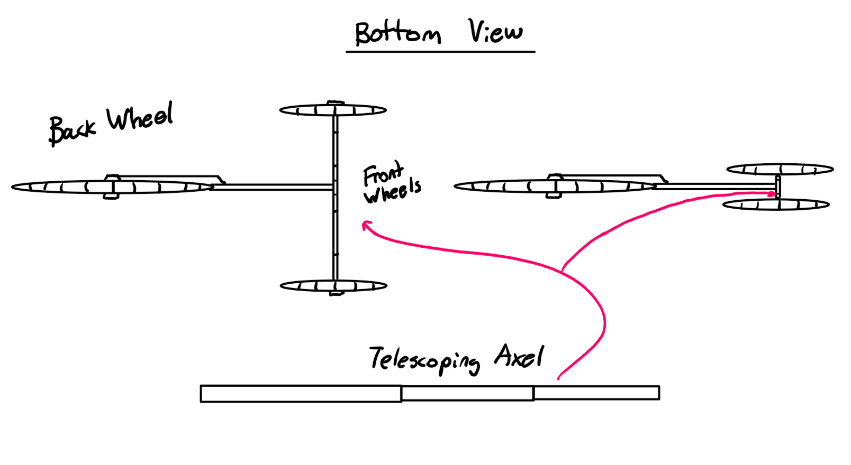

Codin’s Design concept:

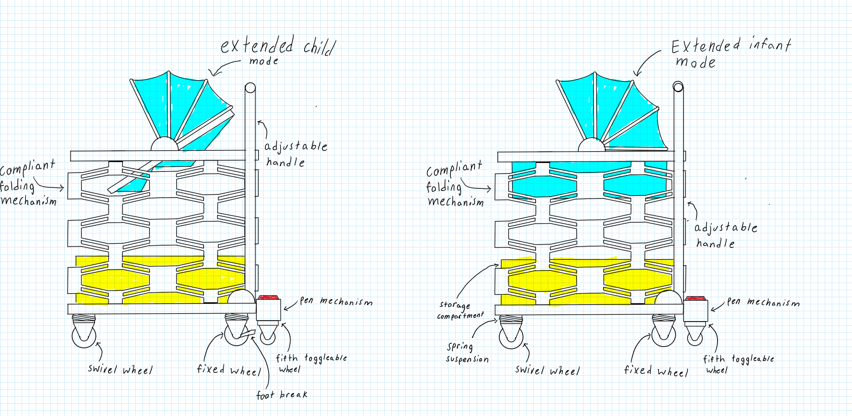

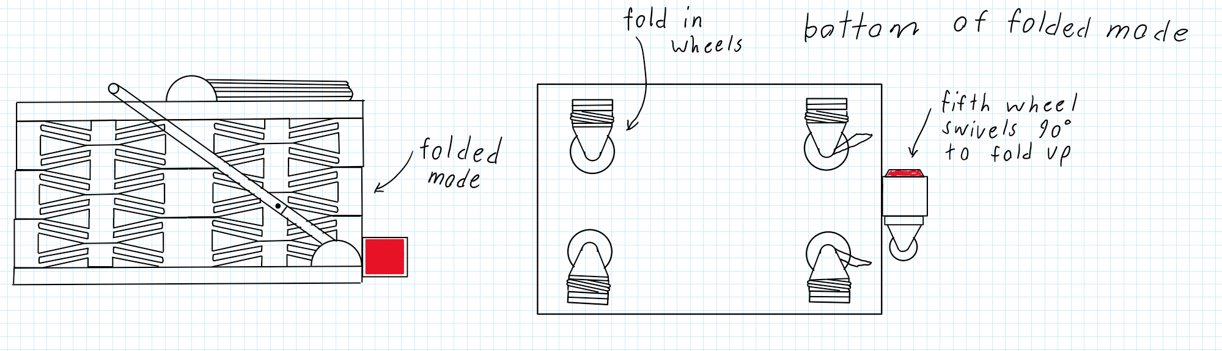

**Andrej’s Design Concept**

The intervention features a magnetic levitation system to reduce weight and increase comfort. It also features a comfortable and large carrier for the child, accommodating children from ages 0-5. The intervention features a stomach/chest mounted push device, letting the entire body push as opposed to just the arms/shoulders. THe intervention also features a hybrid electric system controlled by the two side handles. It can assist in acceleration/movement, braking, and parking. Folding is very easy, as each individual joint is electrically activated. At the push of the disassembly button, each joint unlocks, allowing for motion. All buttons and controls are large and easy to activate, allowing a large amount of users to contribute.

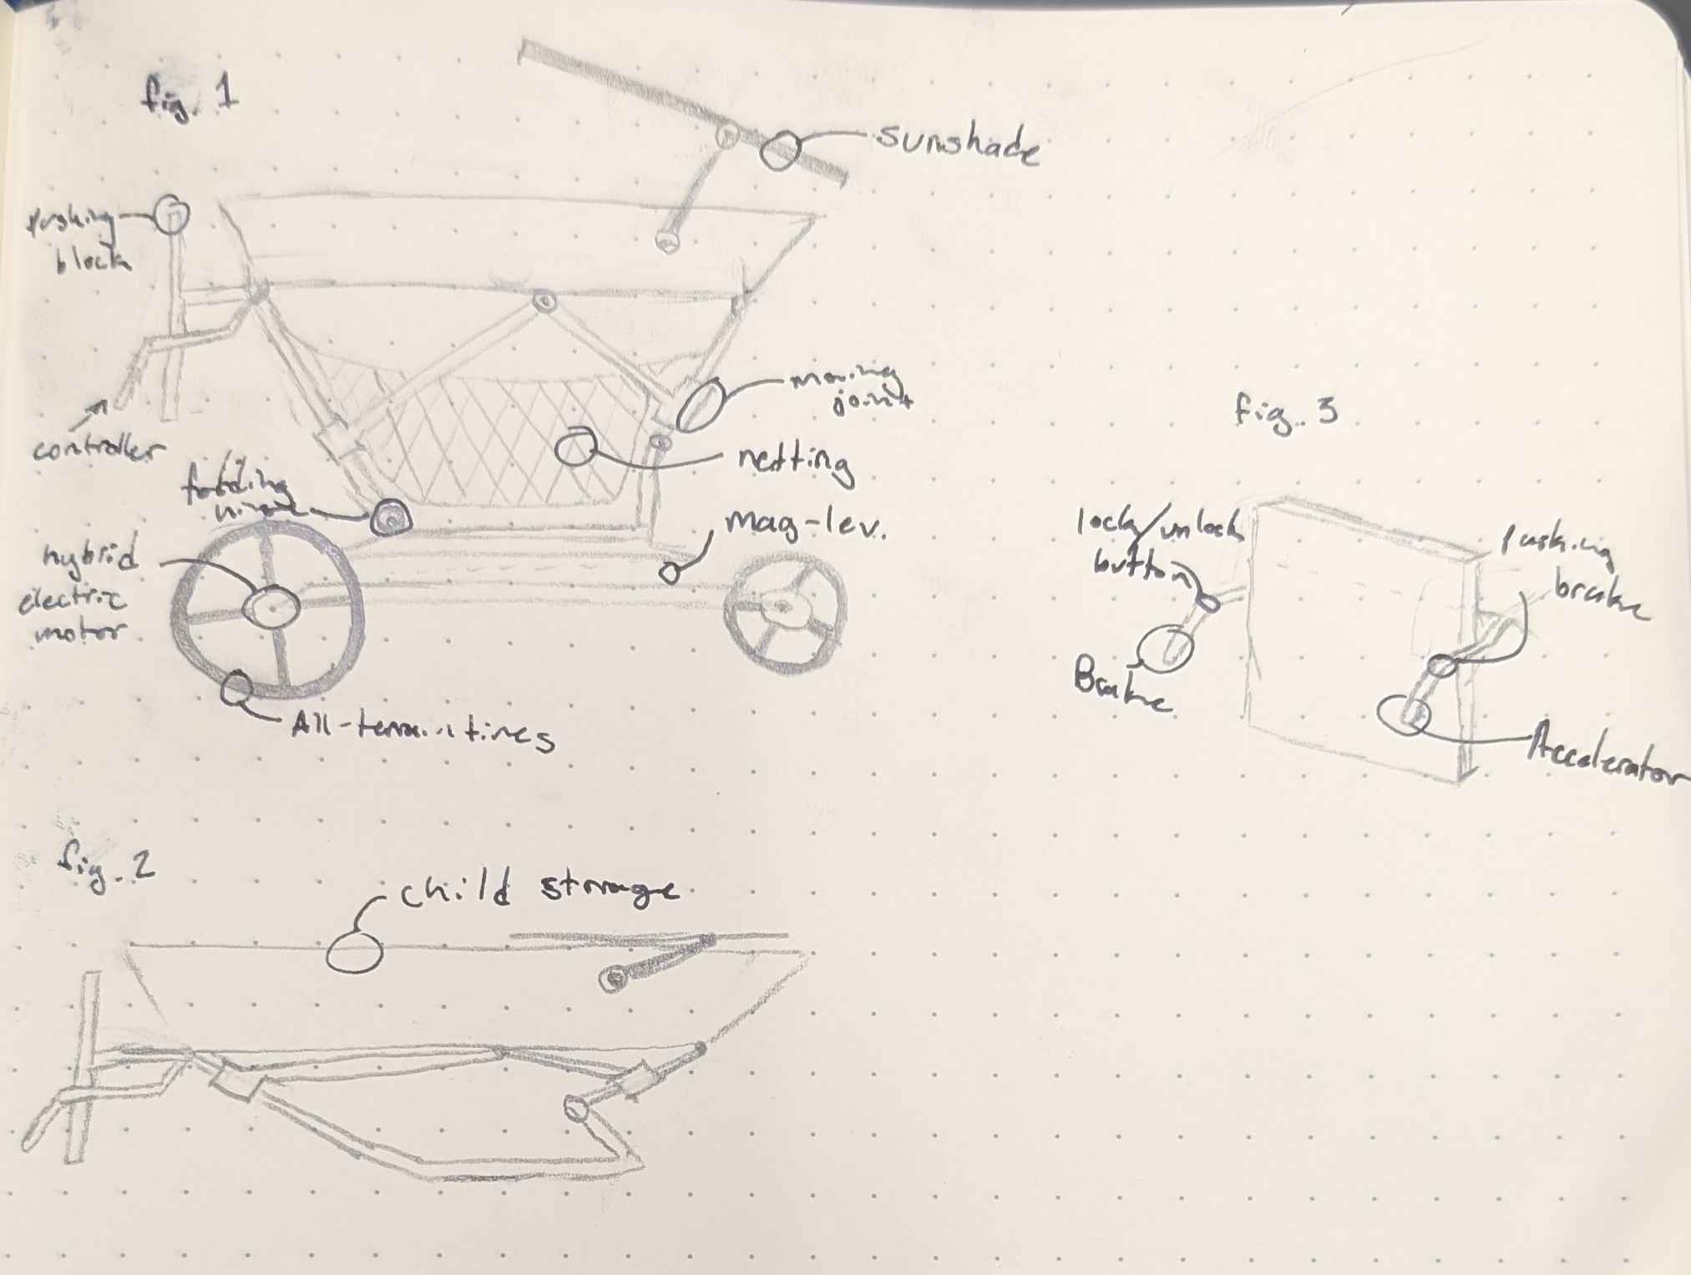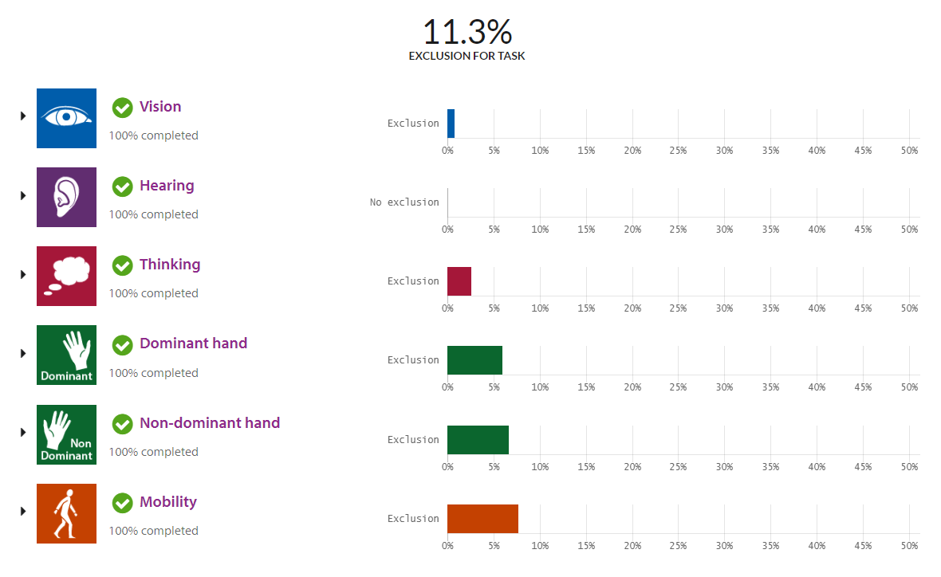

**Yee Yin's Design Concept**

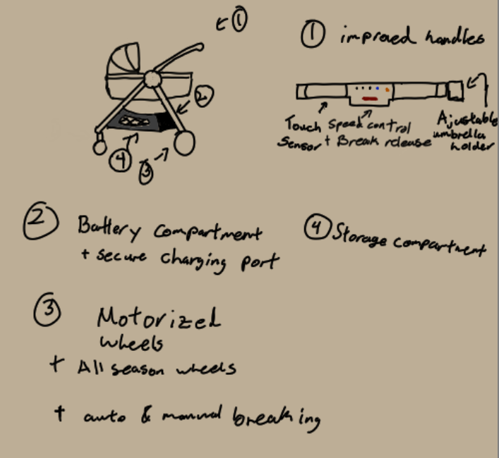

**Osman’s Design Concept**

